AI StudyBuddy
Data Flow Diagram & User Stories
Requirements and Analysis Phase

Project | AI StudyBuddy
Project ID | SWTID-2026-7764
Prepared | 28 September 2026
Source | Current source folders: backend/ and client/
Document status | Project-specific draft based on current backend/client source evidence

Evidence baseline: current source files inspected from the backend/ and client/ folders. node_modules were not required. Claims not visible in source are labelled as implemented, partially implemented, proposed, unverified, or requiring verification.

Document Contents
- Context-Level Data Flow
- Levelled Material Flow
- User Stories
- Authentication Flow
- Entity Relationship
- Claims Requiring Verification

Context-Level Data Flow
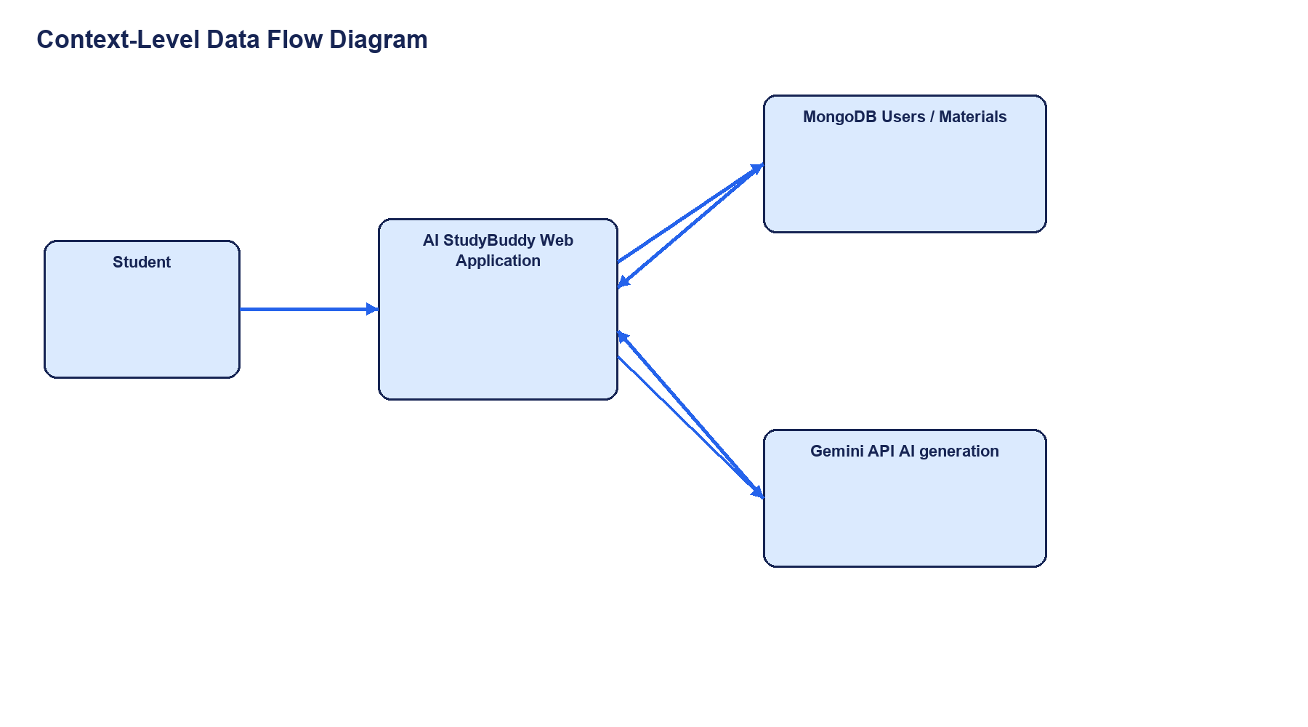
Student data enters the web application; materials and generated outputs move between the API, MongoDB, and Gemini.

Levelled Material Flow
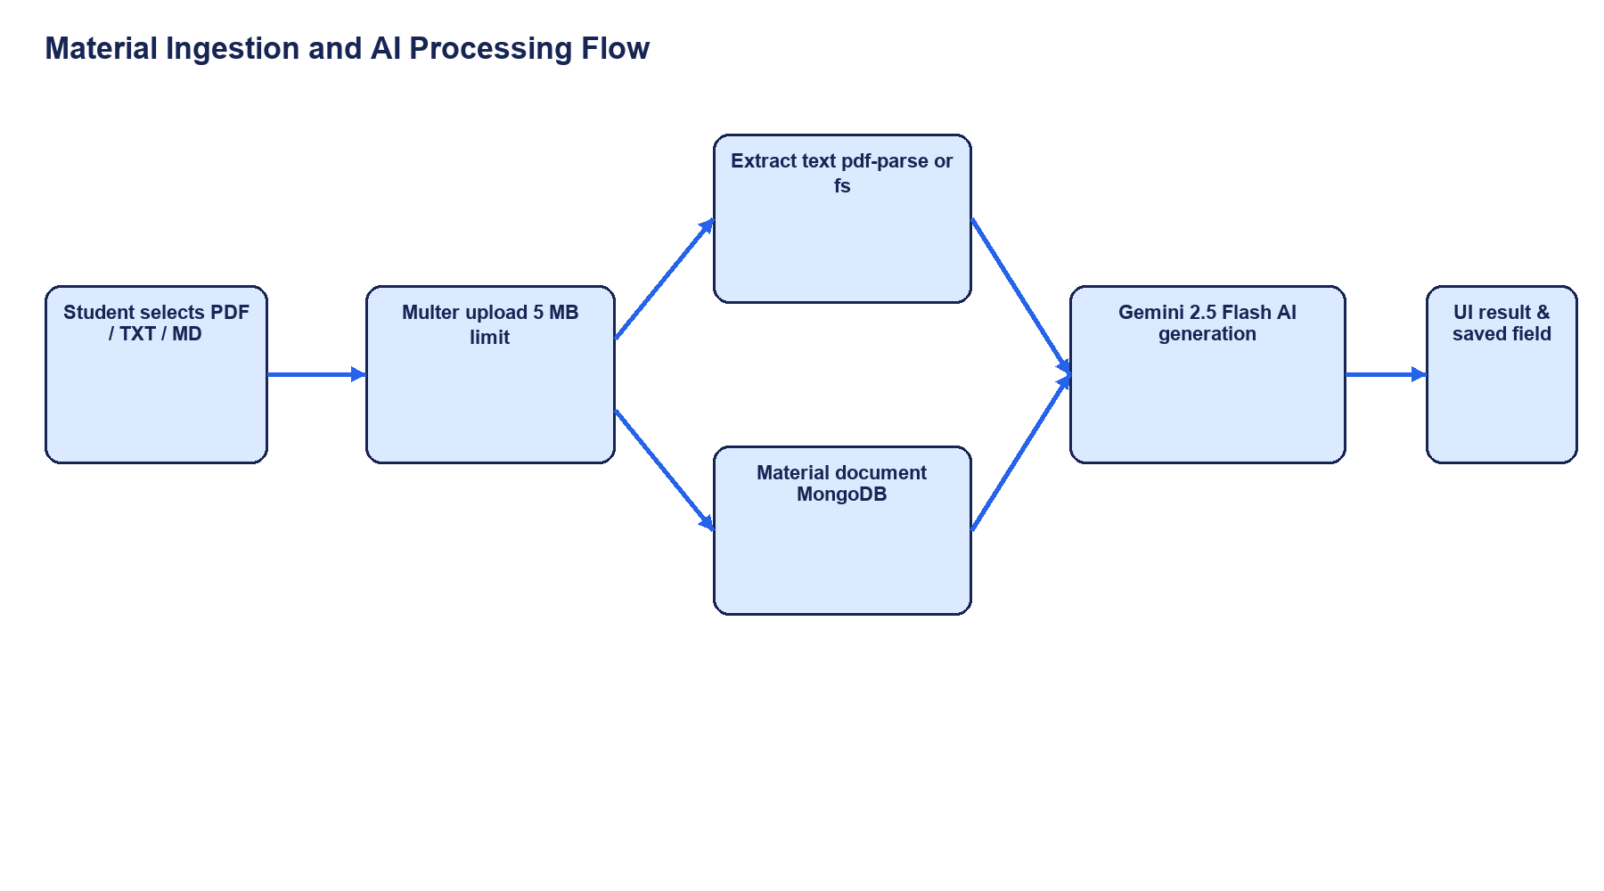
Detailed upload, extraction, persistence, and AI-generation flow.

User Stories
ID | User story | Acceptance criteria
US-01 | As a student, I can register and log in so that my study materials can be protected. | Valid backend credentials return JWTs for Bearer requests; local demo fallback and public role input must be distinguished and hardened.
US-02 | As a student, I can upload a PDF, TXT, or MD file so that it becomes searchable learning content. | Supported file under 5 MB is parsed and saved as a Material.
US-03 | As a student, I can generate a concise summary from my material. | Summary endpoint returns AI text and persists it.
US-04 | As a student, I can generate flashcards for active recall. | Structured question/answer array is returned and displayed.
US-05 | As a student, I can generate and attempt a quiz. | MCQ data is returned; QuizPlayer tracks answers and score.
US-06 | As a student, I can request a study plan. | Plan is generated and stored in the Material studyPlan field.
US-07 | As an administrator, I can inspect users and material counts. | Admin-protected endpoints return users and stats.
US-08 | As an administrator, I can remove a user and their materials. | Delete operation cascades to the user’s Material records.
US-09 | As a student, I can use notes, planner, and analytics in the dashboard. | The frontend provides these interactions; durable persistence is a follow-up requirement.

Authentication Flow
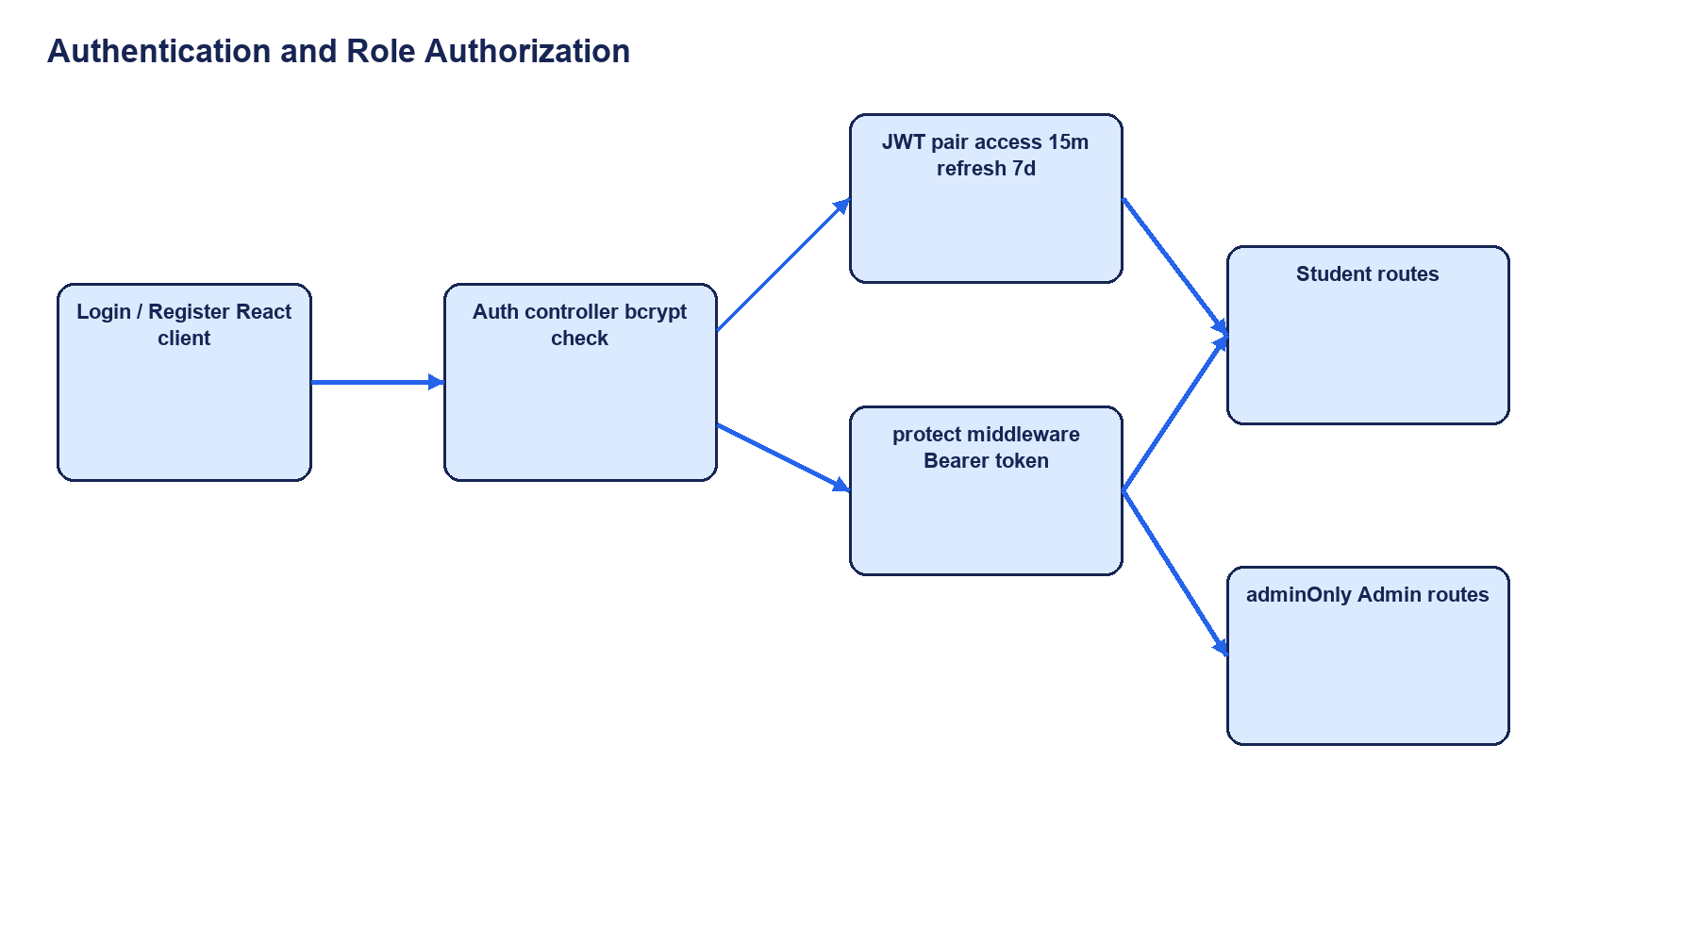
JWT issuance, Bearer protection, refresh behavior, and admin authorization.

Entity Relationship
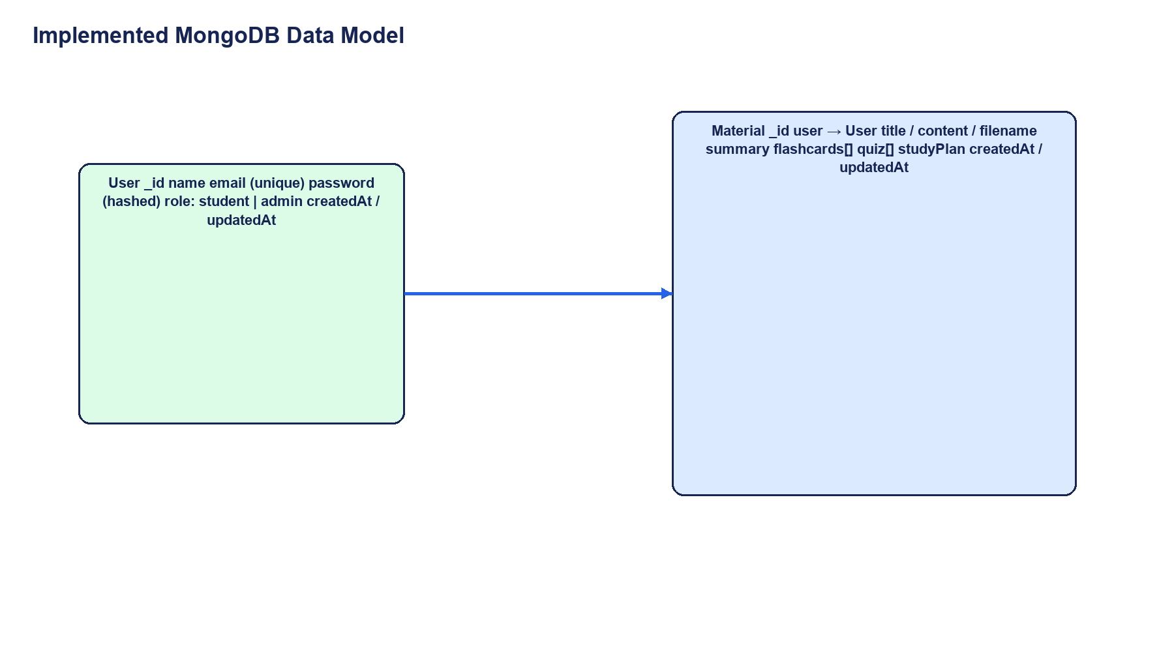
Implemented relationship: one User owns many Material documents; generated learning assets are embedded within Material.

Claims Requiring Verification
Claim | Current evidence | Status / required check
AdminPanel exists and is integrated into DashboardLayout for admin users | No AdminPanel file or admin-only DashboardLayout integration was found in the selected current client source | Unverified; provide the intended source branch/files or confirm the selected folder is current
Automated tests have passed | Backend package uses a placeholder test script and no test suite was found | Unverified; execute UAT and capture evidence
Production deployment is available | No deployment manifests, CI workflow, reverse proxy, or process configuration was found | Unverified; confirm hosting and release configuration
AI output is accurate for all subjects | Generation endpoints exist, but subject-matter quality evidence was not supplied | Unverified; perform expert review with representative materials
Role-based access is secure | Backend protects admin routes, but public registration accepts role and the model permits admin | Security risk; fix and retest before claiming secure authorization

